- Purpose

The purpose of this procedure is to outline the steps necessary to complete the monthly preventive maintenance checks on the Mgo feed system. This includes the Dust collection (external) for the Day Hopper, rotary valves, alarm system, short and long screw conveyor and piping that feeds the liquid and salt side mixing pots.

- Scope

This procedure applies to the MgO Feed System at the Manufacturing Facility. This procedure shall be performed as needed.

- Responsibility

Maintenance Personnel

- Safety Considerations

Safety glasses and appropriate safety apparel are to be worn at all times.

Safety is a condition of employment. Employees are not authorized to work in an unsafe manner and are prohibited from harming the environment of the facility or community.

- Materials/Equipment

N/A

6.0 Procedure

This Preventive Maintenance and/or Repair procedure should be conducted only if it can be performed without interrupting production. If some issue needs to be addressed that requires the system to be halted for any reason then the lead operator should be notified and allowed to take the equipment out of production before work begins.

- Starting at the Dust Collection System for the Day Hopper, visually inspect the exterior of the dust collection to confirm that the doors are sealed properly. Also inspect vent pipe to confirm that it is properly attached to dust collection (not indicative of picture for reference only). This is an exterior leakage inspection and is not the annual inspection completed for air quality.
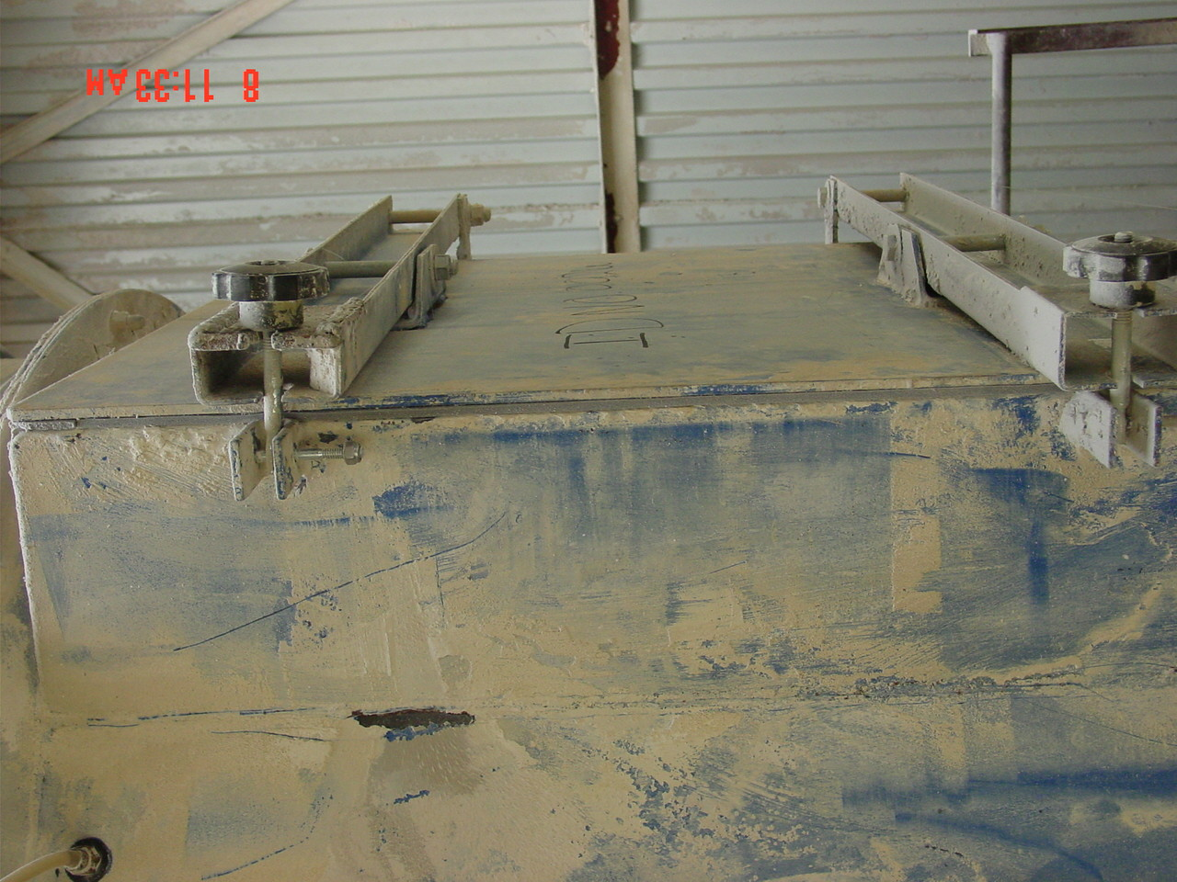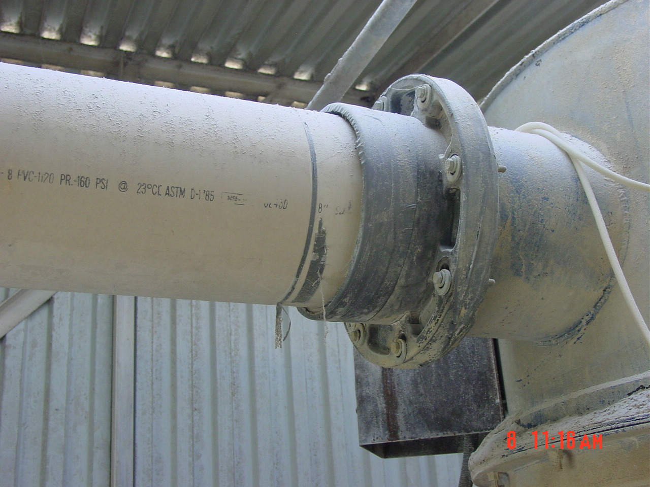
- Inspect rotary valves for packing leaks and proper operation. Also grease appropriate bearings locations on rotary valves under day hopper.
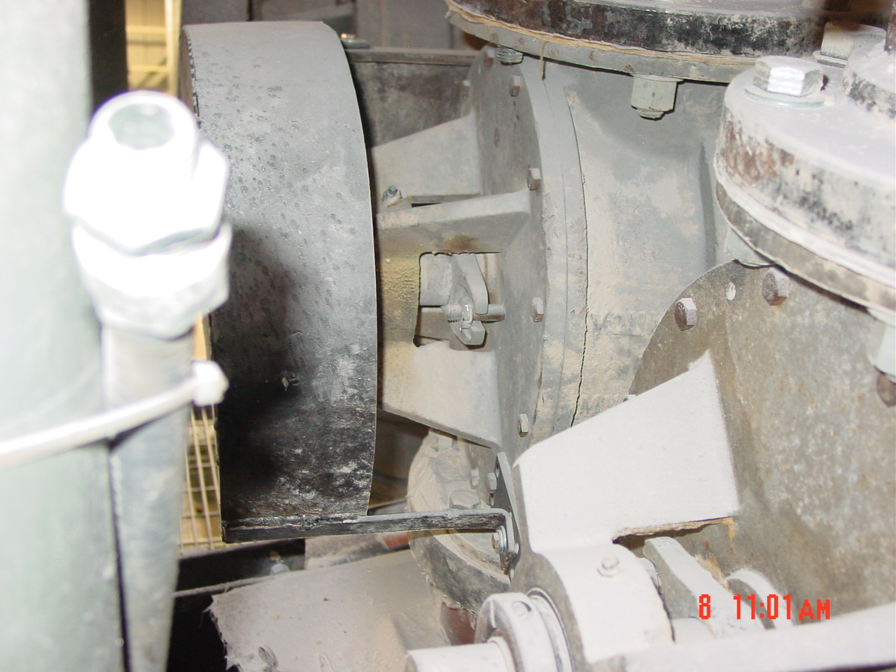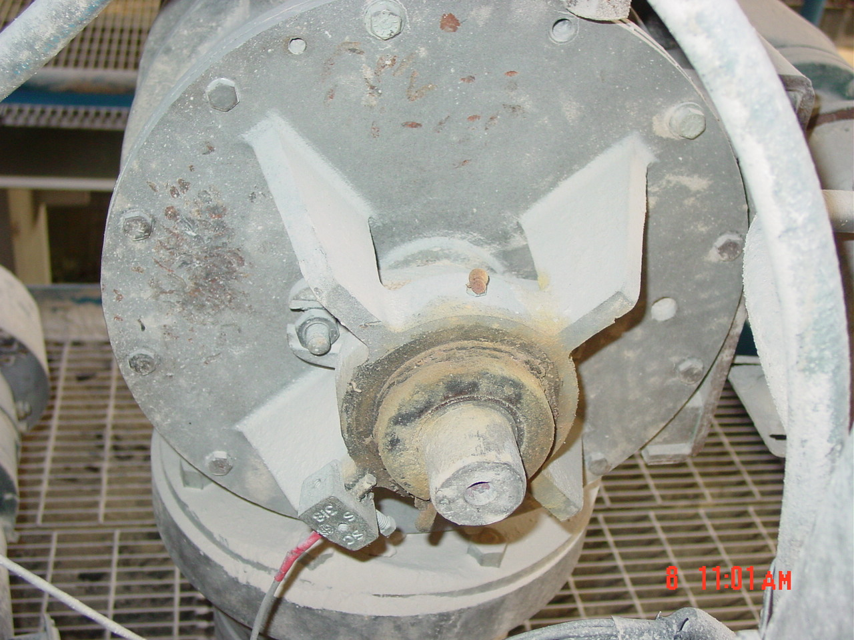
- Grease, lube, and inspect gearbox, motor, chain, and shaft of screw conveyor. Also feed connections from rotary valves to screw conveyors should be inspected for leaks. All leaks should be contained and cleaned up before moving on.
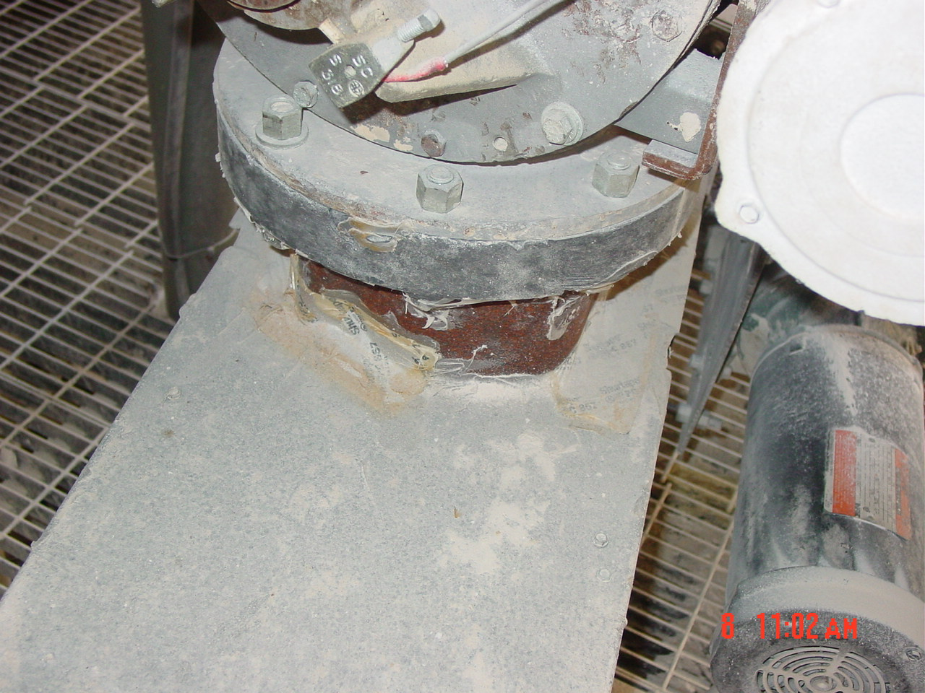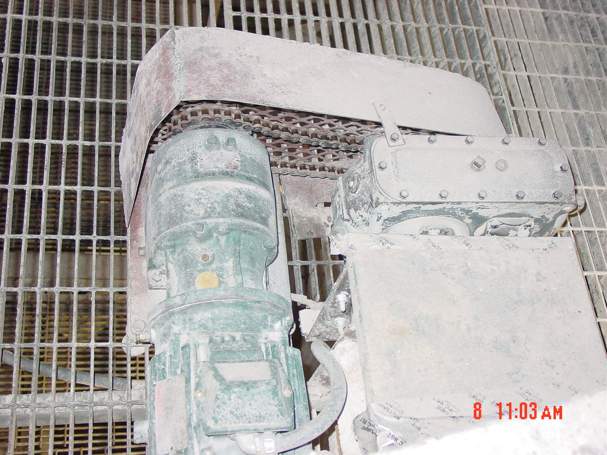
- Again, all grease should be applied to grease fittings on either end of both the liquid and salt side screw conveyors for the Mgo feed system. Inspect all seams on lids to ensure that tape is properly adhered to the surface and any dust contained. If repairs are made to dust containment then area should be cleaned and re-examined to ensure integrity of the system.
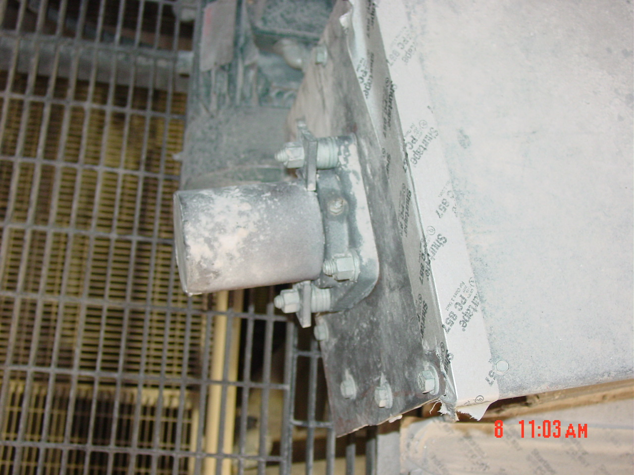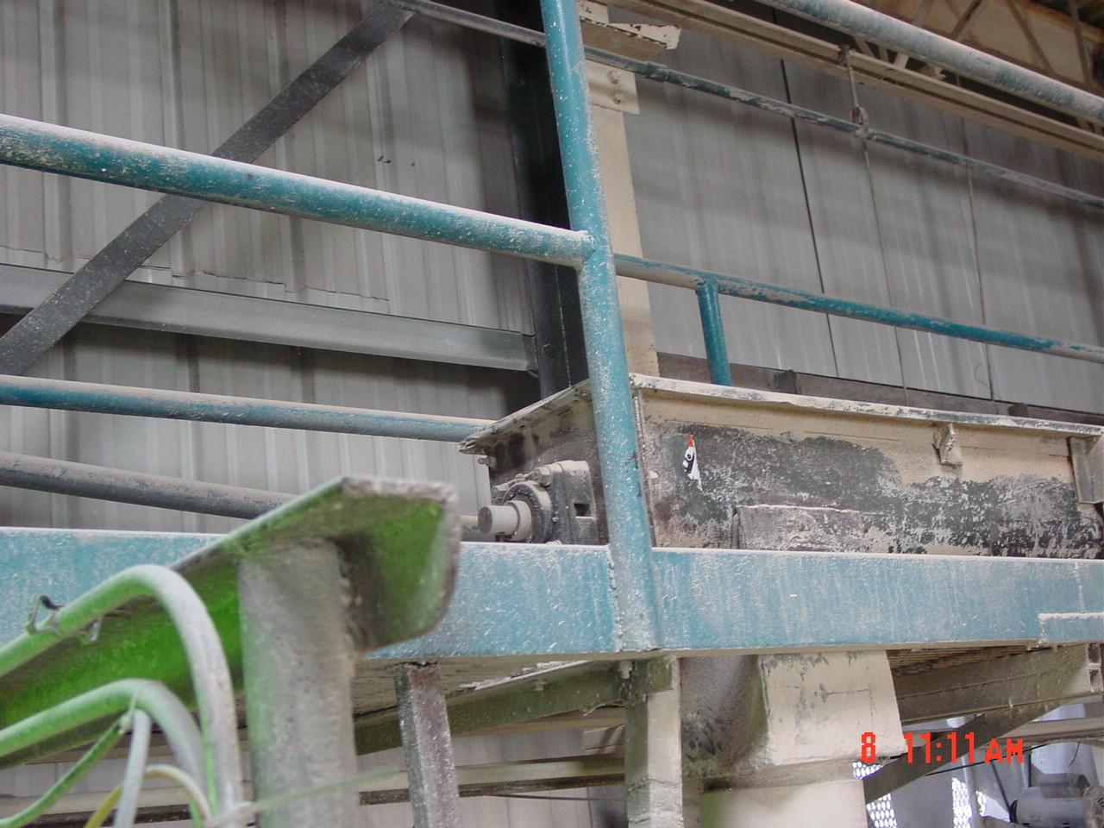
- All lighting within the Mgo Feed System area should be inspected for proper operation and the early warning system for system overload (reference procedure Mgo Delivery System to Digesters) should be inspected visually to ensure it is operational.
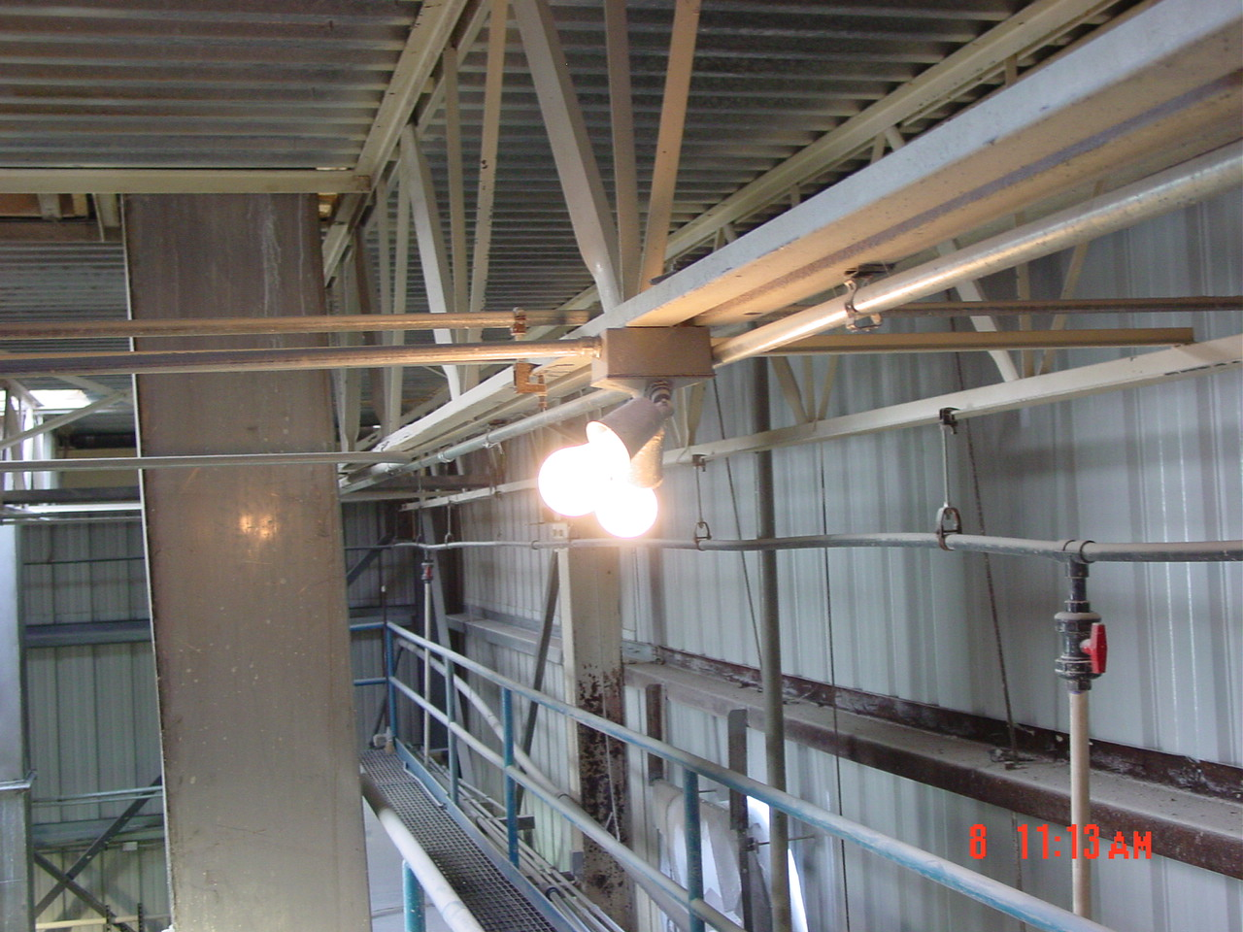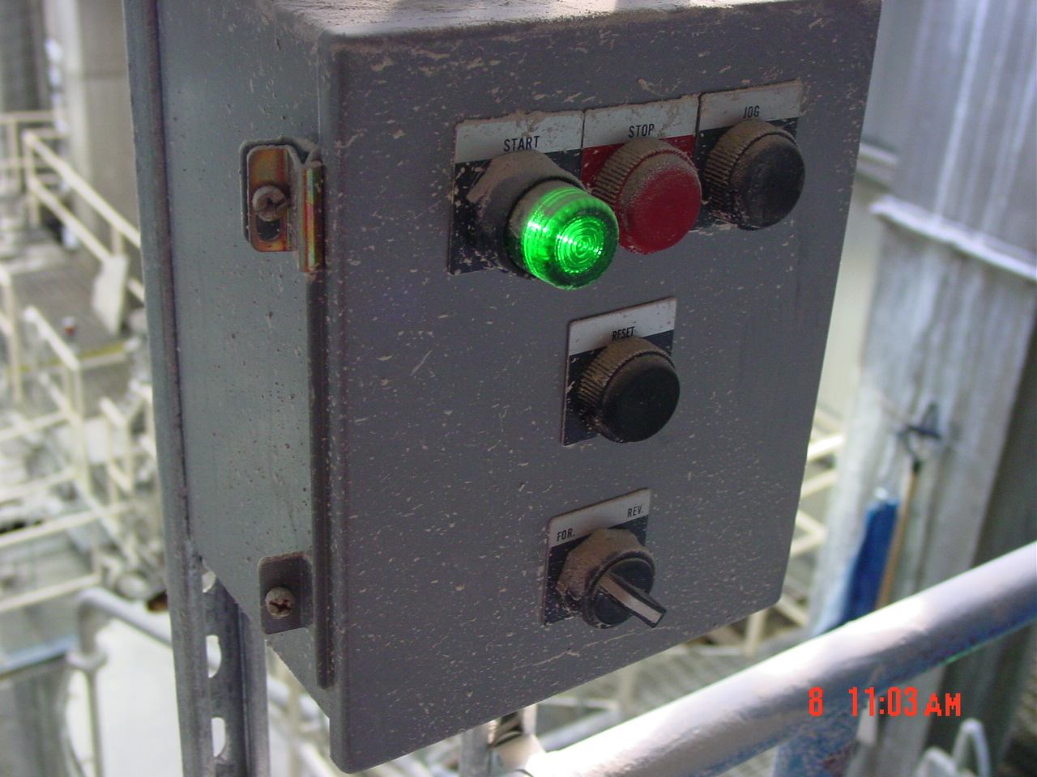

- Reference Documents

N/A

- Change Information

New Document

